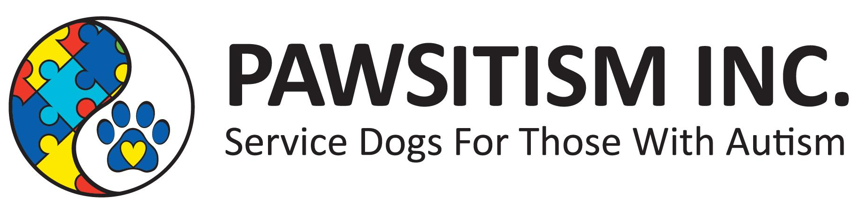
REGISTRATION AND WAIVER
GOAT YOGA/BEER & CHEESE PAIRING
Event forms can be emailed to pawsitism@gmail.com, mailed or dropped off at Ruff Academy on 1221 Erie Avenue, Sheboygan Wisconsin. Payment can be dropped off in person, mailed, or sent via PayPal. Pre-registration deadline will be August 14th, 2020. On-site registration will be available at a higher price. There are limited spots for goat yoga. Dogs are allowed at the event but are not allowed in the goat yoga area. Fees go to the care and training of current and future service dogs for Pawsitism. Receive a free tank top for early registration.
One Registration Per Person. Print Information Clearly.
NAME ▁▁▁▁▁▁▁▁▁▁▁▁▁▁▁▁▁▁▁▁▁▁▁▁▁▁▁▁▁▁▁▁▁▁▁▁▁▁▁▁▁▁
^{First Name} ^{Last Name}
ADDRESS ▁▁▁▁▁▁▁▁▁▁▁▁▁▁▁▁▁▁▁▁▁▁▁▁▁▁▁▁▁▁▁▁▁▁▁▁▁▁▁▁
Street Address City State/zip
DATE OF BIRTH ▁▁▁▁▁▁▁▁▁▁▁ EMAIL ▁▁▁▁▁▁▁▁▁▁▁▁▁▁▁▁▁▁▁▁
^{Month/Day/Year}
PHONE ▁▁▁▁▁▁▁▁▁▁▁▁▁▁▁▁ DOG(S) Name(s) ▁▁▁▁▁▁▁▁▁▁▁▁▁▁▁
TANK TOP SIZE
◯ Small ◯ Medium ◯ Large ◯ XL ◯ XXL
Check the Event You Wish To Participate
◯ Goat Yoga - $25 per person (Choose a session)
◯ Session 1 @ 12:30 pm ◯ Session 2 @ 1:45 pm
◯ Session 3 @ 3:00 pm ◯ Session 4 @ 4:15 pm
◯ Beer and Cheese Pairing - $25per person
◯ Goat Yoga AND Beer and Cheese Pairing - $40 per person
(Please choose yoga session above)
Liability Waiver and Full Publicity Release Pawsitism Inc discloses there are risks involved in the participation of Goat Yoga and Beer and Cheese Pairing. These include but are not limited to injuries due to the movement, slipping, falling, and dog bites. As a willing participant, I acknowledge the risks involved to myself, my property, and dog. I waive and release any and rights and claims of damages or injuries arising out of, or in any way related to my participation in this event. I certify that I am healthy and fit to participate in this event. I will always maintain and control my dog at the event, and not allow it to disrupt other people or animals at the event, and I will clean up after my dog if it will make a mess. I certify my dog is up to date on their rabies vaccination and can supply proof through a tag or certificate. Hereby I grant Pawsitism Inc. the rights to record, broadcast, film, or photograph my likeness for use of publicity or promotional use as Pawsitism Inc. will desire without my consent or knowledge. I HAVE HAD SUFFICIENT TIME TO READ THIS ENTRE DOCUMENT. I HAVE READ AND UNDERSTOOD THIS DOCUMENT, AND I AGREE TO ITS TERMS. I HAVE SIGNED IT FREELY AND UNDERSTAND I AM GIVING UP SUBSTANTIAL RIGHTS BY SIGNING IT.
Printed Name ▁▁▁▁▁▁▁▁▁▁▁▁▁▁▁▁▁▁▁▁▁▁▁▁▁▁▁▁▁▁▁▁▁▁▁▁
Signature▁▁▁▁▁▁▁▁▁▁▁▁▁▁▁▁▁▁▁▁▁▁▁▁▁▁▁▁▁▁▁▁▁▁▁Date▁▁▁▁▁▁▁▁

